Newsletter now being printed by Katie DeehanPhone 087 926 4456 or e-mail: kilglassparishnewsletter@outlook.com Deadline 9pm latest on Thursdays for inclusion.
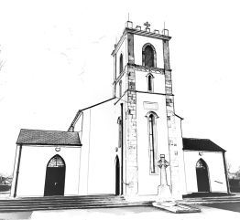
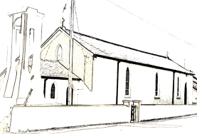
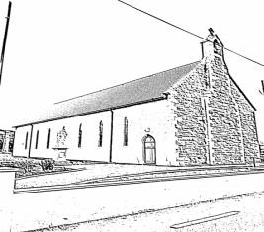
Our Lady of Mount Carmel Church, Rooskey
Slatta
St. Anne’s Church, Slatta

Church of The Sacred Heart, Kilglass

CHURCH NOTICES
- Next Sunday 29th November is First Sunday of Advent. Let us specially take note of the penitential character of this Season of the Church.
- Pope's intention for the month of December: Intention for evangelisation - For a life of Prayer.
We pray that our personal relationship with Jesus Christ be nourished by the Word of God and a life of Prayer.
- To mark the end of November, dedicated for prayers for the dead, on Saturday 28th of November, we shall have a special Mass for all the deceased priests who have served in our Parish. The Mass will take place at 7.30p.m.
- We are not certain that we shall have public Masses at Christmas but assuming that we can, we should please take care in our own community now and through Advent to do all we can to reduce infection rate of the virus by avoiding close contacts that give the virus an opportunity to spread. Above all let us pray regularly the "Prayer in the Time of the Corona Virus" by Fr. Brian Grogan S.J.
Masses: All Masses will be streamed live on ChurchTV/Rooskey
"One word or a pleasing smile is often enough to raise up a saddened and wounded soul". (St. Therese of Lisieux)

Masses & Intentions this week: (Monday 23rd- Sunday 29thNovember 2020)
Sunday 22th November | Church of Our Lady of Mount Carmel, Rooskey | 11.30 a.m. | Anniv Mass for John & Margaret McHugh. Month's Mind Mass for Frank McGuire.
Tues, Wed & Thurs 24th, 25th & 26th  November | Church of Our Lady of Mount Carmel, Rooskey | 10.00 a.m.

Friday 27th November | Church of Our Lady of Mount Carmel, Rooskey | 10.00 a.m. | 1st Anniv Mass for P.J. Farrell also his parents Teresa and Edward and brothers Noel and Aloysius.
Saturday 28th November | Church of Our Lady of Mount Carmel, Rooskey | 10.00 a.m.
Saturday 28th November | Church of Our Lady of Mount Carmel, Rooskey | 7.30 p.m. | Special Mass for all of the deceased priests who have served in our parish
Sunday 29th November | Church of Our Lady of Mount Carmel, Rooskey | 11.30 a.m. | Anniv. Mass for Paddy Harte, Slatta
ROSARY: immediately after 10 a.m. Mass on Tuesdays & Fridays, Fr. Evaristus will lead the Rosary which will be streamed live on ChurchTV/Rooskey. Everyone is invited and encouraged to join him.
RECENT DEATHS: Please pray for the repose of the soul of John Geoghegan, Castleknock, Dublin and Mullagh, who was laid to rest during the week. May his soul rest in peace.
Doctors’ Rota:
Rooskey Medical Centre 071 963 8024
Please contact the surgery to arrange consultation, repeat prescriptions or any other medical issues. Due to COVID-19 restrictions, you will be offered a phone back from the GP in order to triage your needs and arrange consultation if necessary. For Out of Hours emergencies please contact MIDOC at 1850302702.
COMMUNITY NOTICES
ONLINE CLASSES: Galway/Roscommon ETB are running Online Winter Classes in November & December to include Art, Health & Fitness/Exercise, Yoga, Craft, Vegetarian Cooking, Winter Gardening, Flower Arranging, Basic Sewing and Digital Photography. If interested call Patricia at 086 8534100 or 071 9658631 between 10.30am - 1pm, Monday to Friday.
KILGLASS GAELS LOTTO: Numbers drawn 14th November 2020: 25, 3, 7, 12 BONUS No. 8. No jackpot winner, 1 x €200, Kelly Kids. Next Week’s Jackpot: €12,400 for 4 correct numbers, €16,400- for 4 correct numbers PLUS bonus number.
KILGLASS LADIES BONUS BALL: Wednesday 18th November No. 41, winners: Charlie Smith and Dermot Washington, €50 each
MAYO/ROSCOMMON HOSPICE: Christmas cards and Shine a Light cards can be purchased from the usual people this year and are now available. Thank you for your continued support

